1.INTRODUCTION

1.1 Overview

Tech-Pro solutions is an information technology solutions company known for helping its clients achieve their business objectives. Global in scope, we provide experienced information technology and engineering professionals at the right time and the right place to meet our clients’ mission-critical technology needs.

Through on-site staffing, specialized development, off-shore staffing, or a combination of all three, we are able to support the IT challenges, timeframes, and budgets of any organization

1.2 Purpose

We utilize the latest technology to provide sophisticated and secure IT solutions using an effective delivery model to ensure flexibility and agility. Our “High performance business” strategy builds on our expertise in consulting, technology and outsourcing to help clients perform at the highest levels so that they can create sustainable value for their customers

2. PROBLEM DEFINITION & DESIGIN THINKING

2.1Empathy map

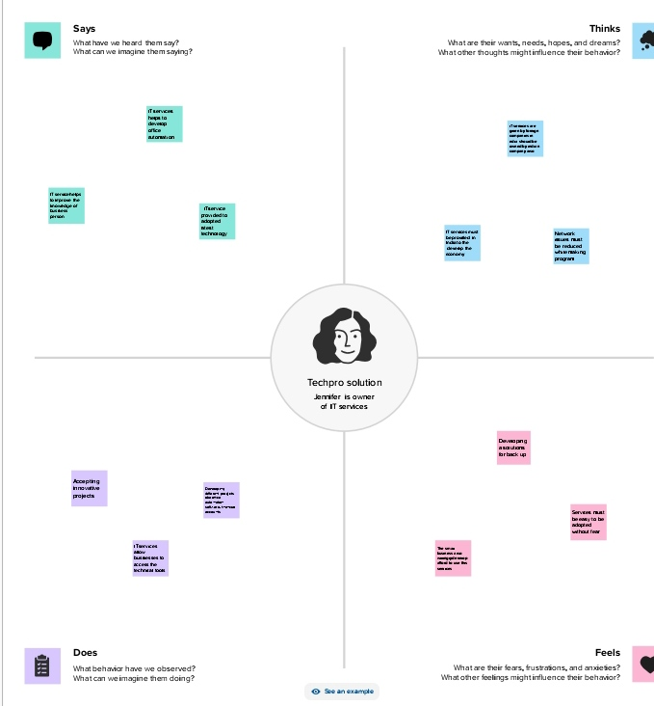

2.2 Ideation & Brainstorming map

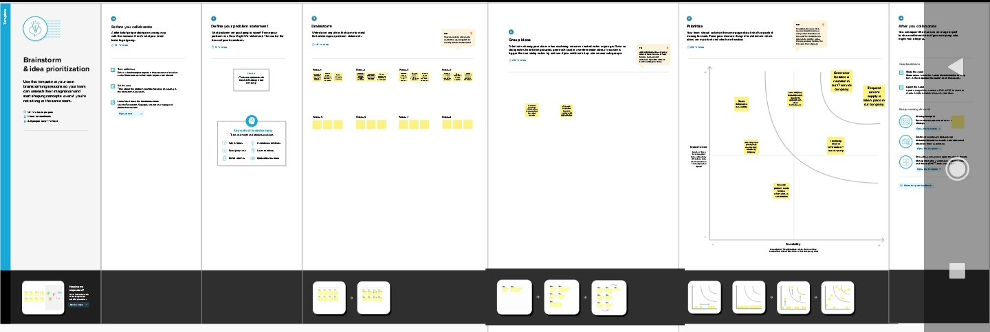

Results

Information technology plays an essential role in almost every aspect of modern life. It is used in many industries to increase efficiency and productivity and reduce costs. IT protects data and other sensitive informations.

The output of profit and loss for Zoho Company from 01/04/2023 To 30/04/2023 for the year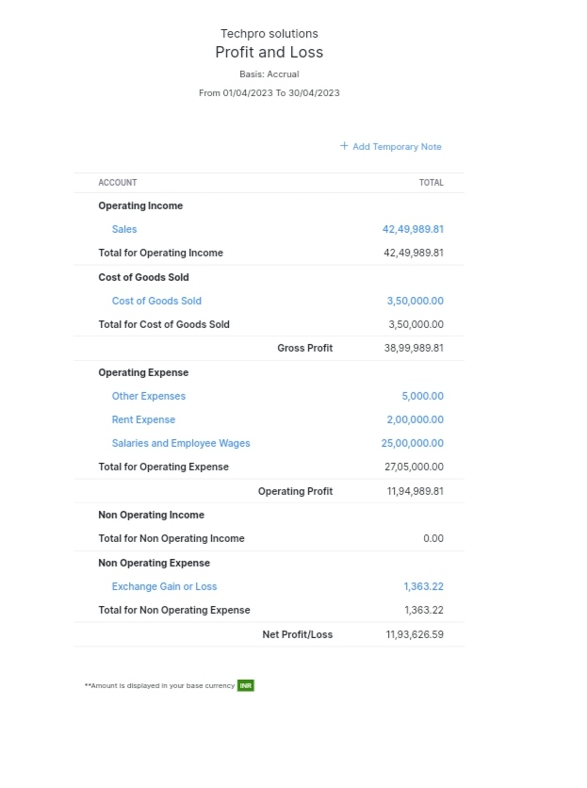

The balance sheet as on 08/05/2023 with the Total Assets and the Total Liabilities of rs.2286626.59

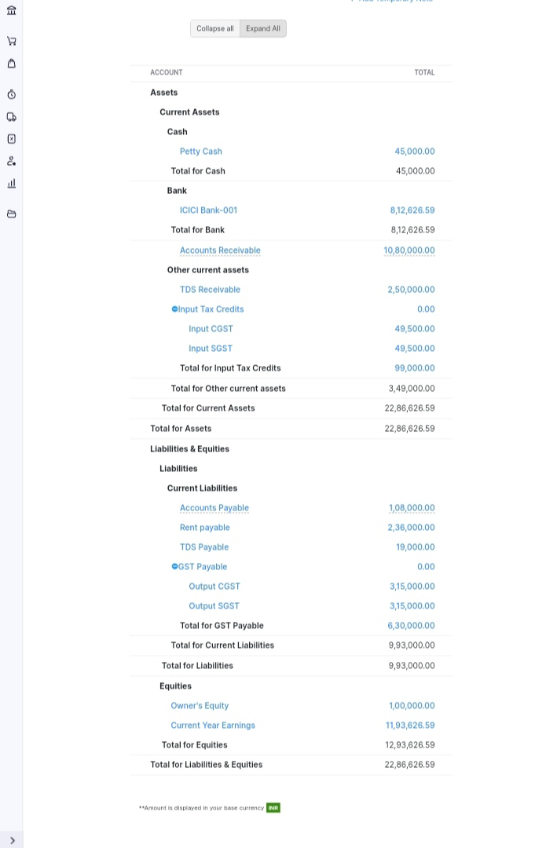

Creating Items:

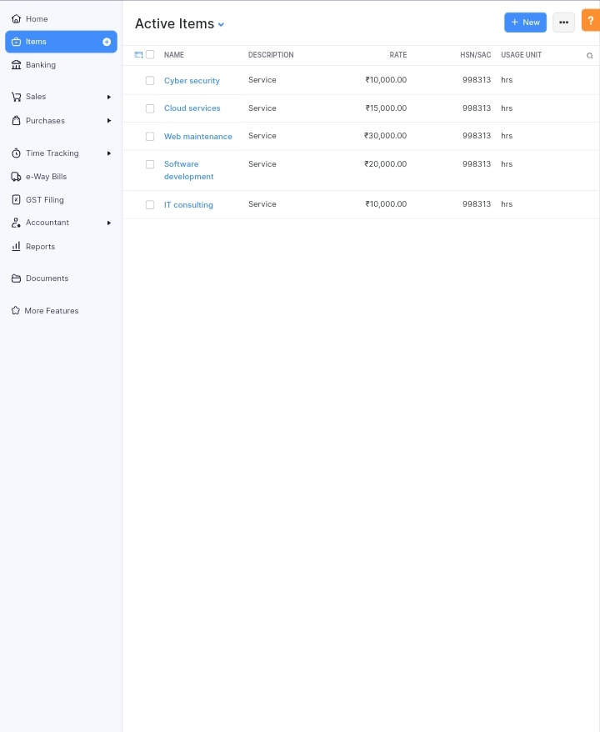

Active vendors:

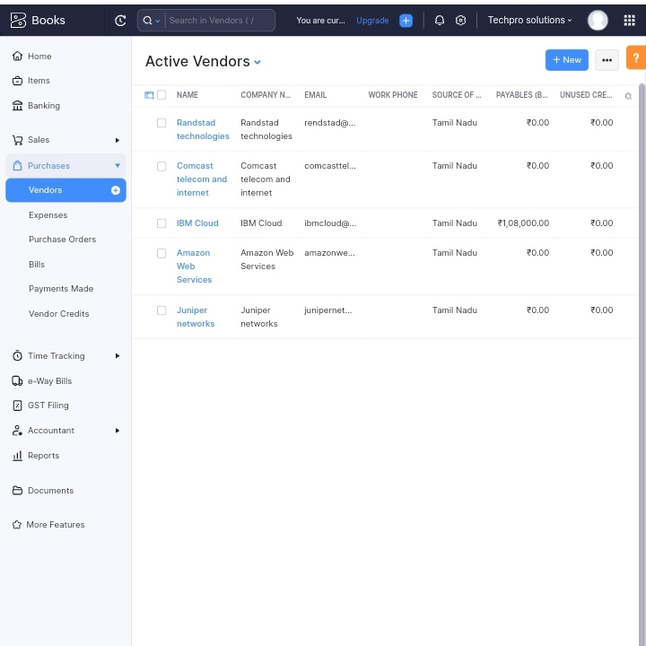

Purchase order:

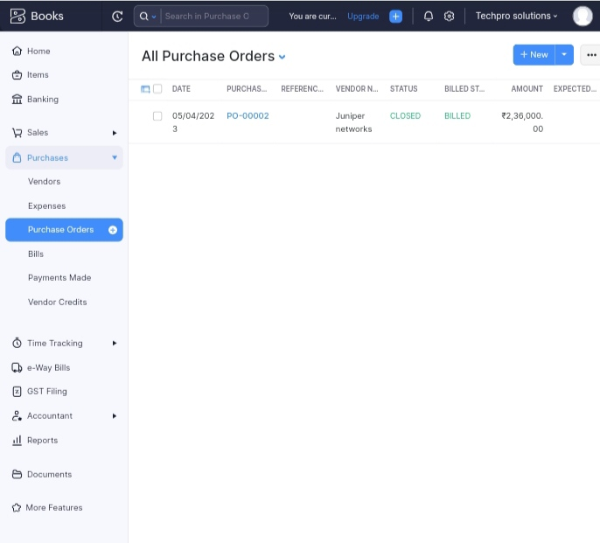

Bills:

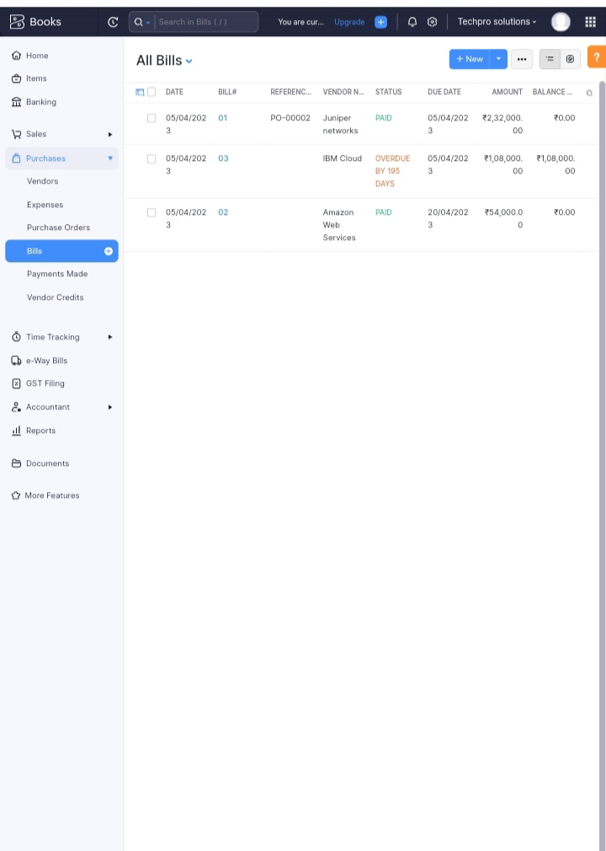

Active customers:

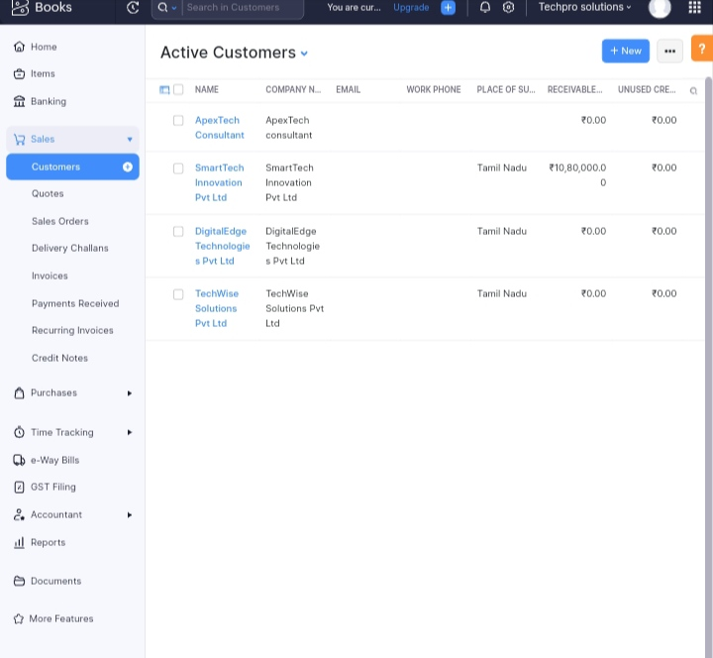

Sales Order:

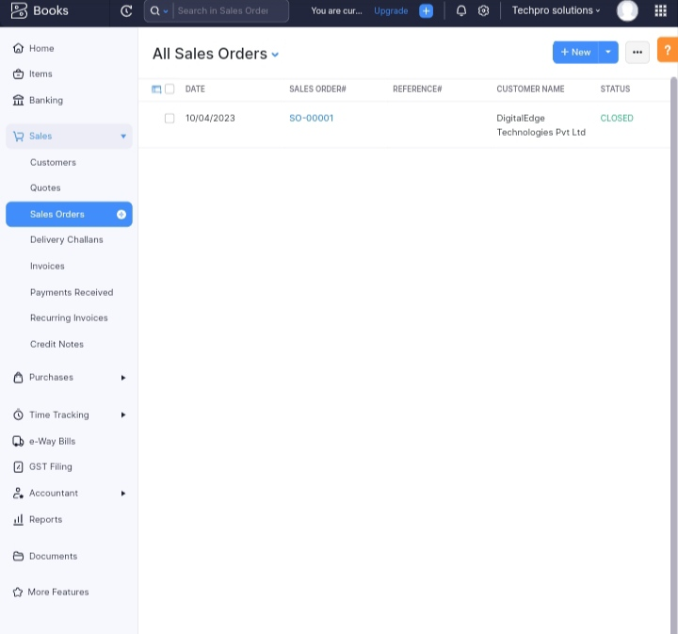

All Invoices

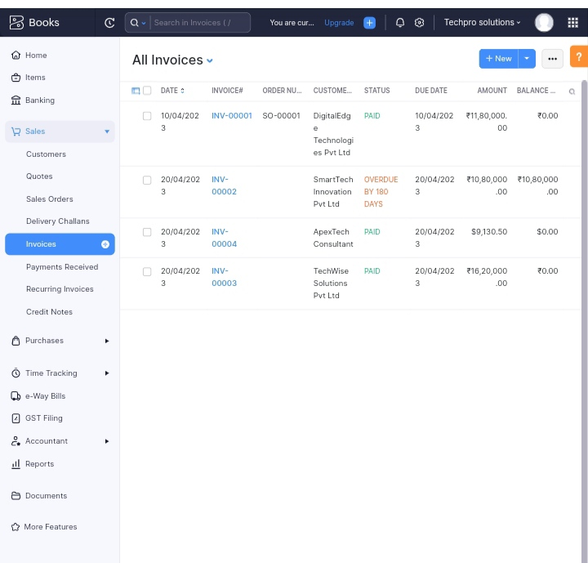:

Banking:

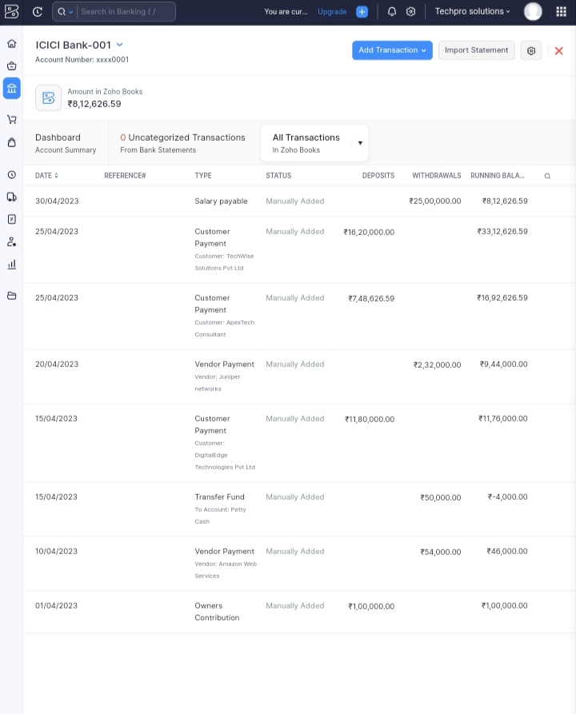

GST summary:

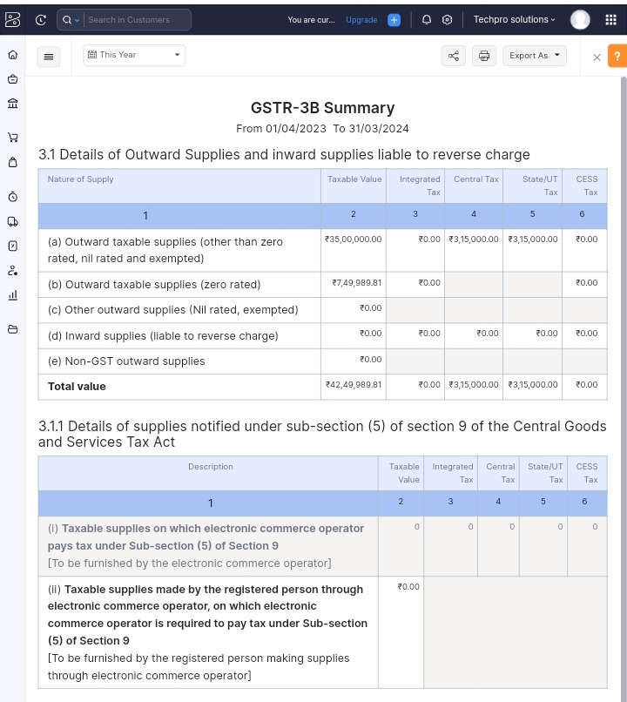

Eligible ITC

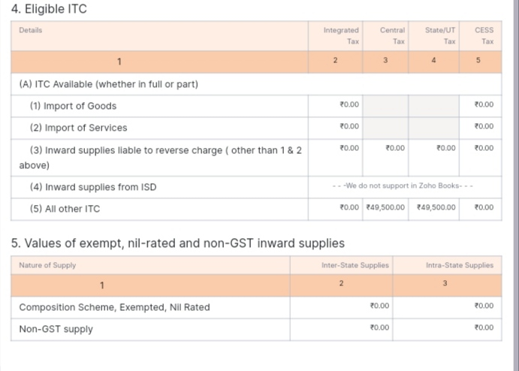

Tax Return

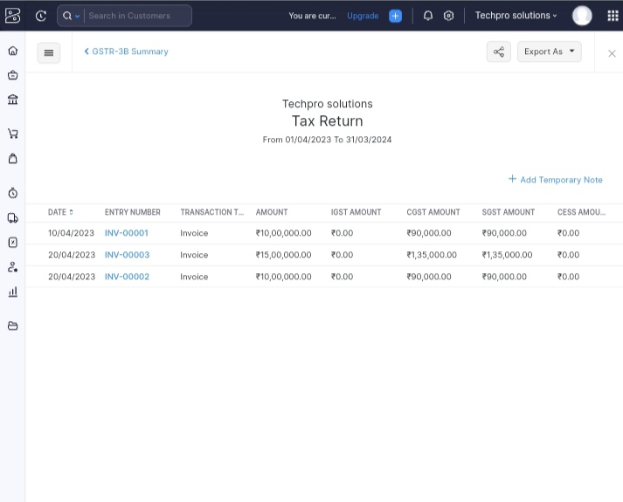

ADVANTAGES AND DISADVANTAGES

Advantages:

Manage different aspects of industry operations efficiently with easy access to critical moments

Create easily customizable and user-friendly forms to quickly gather information.about purchases

Disadvantages:

It does have a certain level of complexity that may not be suitable for businesses with limited technical expertise. This could impact the ease of implementation and adoption.

All Zoho Books plans set a maximum number of invoices you can issue per year. Zoho Books also lacks features for calculating any type of tax other than sales tax.

Difficult to balance your personal life. Full-time employment can be rigorous, requiring your full commitment for most of the week (normally 40 hours from 9 am to 5 pm).

APPLICATIONS:

Customer relationship management application software

Enterprise resource planning application software

Project management application software

Database

Resource management application software

CONCLUSIONS:

Preparation and maintenance of zoho books for Techpro solutions

FUTURE SCOPE:

Internet BankingIt allows you to manage your projects from budgeting to logging time and invoicing customers effectively. Moreover, Zoho Books Software lets you record the time spent on tasks and avoid overbilling and underbilling your customers